1.0 Introduction
The normal Pokémon games have many evolutions that require trading to achieve. While the advent of Wi-Fi and the GTS glitch has made it easier, it’s still quite a hassle, so every Pokemon that needs trading has been given an alternate evolution method, requiring them to level up with the usual item at either day or night depending on what Pokemon it is. Regular trade evolutions simply evolve by level.

There is also a problem with Eevee, Nosepass and Magneton. These three all need to be in specific areas in Sinnoh or Unova to evolve into their next forms, but there is nowhere in Johto or Kanto for them to achieve an evolution. As such, they have also been given new evolution methods with items.

Feebas has also been given a new evolution method; while Beauty evolution is possible through Daisy, it’s too late and too much hassle.

1.1 Evolution Changes
The Pokémon below – listed in order of National Dex by the unevolved form – are affected by the evolution changes.

Unevolved Pokemon | Methods | Evolved Pokemon
 | Evolve via;  - Trade w/King’s Rock  - Hold King’s Rock and level at Night | 
#061 POLIWHIRL |  | #186 POLITOED

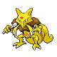 | Evolve via;  - Trade  - Level 36 | 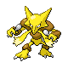
#064 KADABRA |  | #065 ALAKAZAM

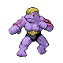 | Evolve via;  - Trading  - Level 38 | 
#067 MACHOKE | Evolve via;  - Trading  - Level 38 | #068 MACHAMP

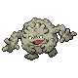 | Evolve via;  - Trading  - Level 35 | 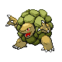
#075 GRAVELER | Evolve via;  - Trading  - Level 35 | #076 GOLEM

 | Evolve via;  - Trade w/King’s Rock  - Hold King’s Rock and level at Day | 
#079 SLOWPOKE |  | #199 SLOWKING

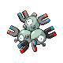 | Evolve via;  - Hold Magnet and level at Day | 
#082 MAGNETON | Evolve via;  - Hold Magnet and level at Day | #462 MAGNEZONE

 | Evolve via;  - Trading  - Level 35 | 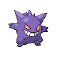
#093 HAUNTER | Evolve via;  - Trading  - Level 35 | #094 GENGAR

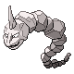 | Evolve via;  - Trade w/Metal Coat  - Hold Metal Coat and level at Night | 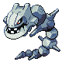
#095 ONIX |  | #208 STEELIX

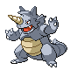 | Evolve via;  - Trade w/Protector  - Hold Protector and level at Day | 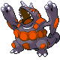
#112 RHYDON |  | #464 RHYPERIOR

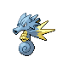 | Evolve via;  - Trade w/Dragon Scale  - Hold Dragon Scale and level at Night | 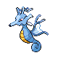
#117 SEADRA |  | #230 KINGDRA

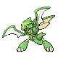 | Evolve via;  - Trade w/Metal Coat  - Hold Metal Coat and level at Day | 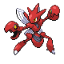
#123 SCYTHER |  | #212 SCIZOR

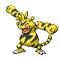 | Evolve via;  - Trade w/Electirizer  - Hold Electirizer and level at Night | 
#125 ELECTABUZZ |  | #465 ELECTIVIRE

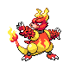 | Evolve via;  - Trade w/Magmarizer  - Hold Magmarizer and level at Night | 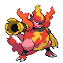
#126 MAGMAR |  | #466 MAGMORTAR

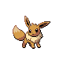 | Evolve via;  - Hold Miracle Seed and level up at Day (Leafeon)  - Hold NeverMeltIce and level up at Night (Glaceon) | 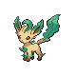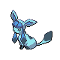
#133 EEVEE |  | #470 LEAFEON  #471 GLACEON

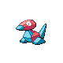 | Evolve via;  - Trade w/Up-Grade  - Hold Up-Grade and level at Night | 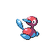
#137 PORYGON |  | #233 PORYGON2

 | Evolve via;  - Trade w/Dubious Disc  - Hold Dubious Disc and level at Night | 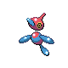
#233 PORYGON2 |  | #474 PORYGON-Z

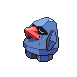 | Evolve via;  - Hold Magnet and level at Night | 
#299 NOSEPASS | Evolve via;  - Hold Magnet and level at Night | #476 PROBOPASS

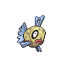 | Evolve via;  - Level w/Max Beauty  - Hold Dragon Scale and level at Night | 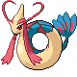
#349 FEEBAS |  | #350 MILOTIC

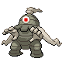 | Evolve via;  - Trade w/Reaper Cloth  - Hold Reaper Cloth and level at Night | 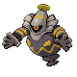
#356 DUSCLOPS |  | #477 DUSKNOIR

 | Evolve via;  - Trade w/DeepSeaTooth (H)  - Trade w/DeepSeaScale (G)  - Hold DeepSeaTooth and level at Night (H)  - Hold DeepSeaScale and level at Night (G) | 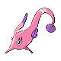
#366 CLAMPERL |  | #367 HUNTAIL  #368 GOREBYSS

